

**NPG Helps**

**Steps to Temporarily Stop Federal Student Loan Deductions**

Does your organization need a way to temporarily stop all federal student loans at a system level vs individual level? This guide will provide step by step instructions to set up an element group that will exclude the Student Loan element from processing in the payroll calculation during this temporary period.

Should you have any questions, please feel free to email us at [NPGHelps@northpointgroup.com](mailto:NPGHelps@northpointgroup.com).

Version: 1.0

Date Created: 03/27/2020

www.NorthPointGroup.com

Options

1. Utilize an Element Set and exclude the Involuntary Deduction
2. Create a Hard Skip Rule and attach the skip rule to the Involuntary Deduction

Option 1 Setup: Element Set

Create Element Set

Payroll Calculation > Object Groups

Create an Element Object Group

* Define a **Name**
* Attach to the United Stated **Legislative Data Group**
* Select Element Group as the **Type**
* Click Continue

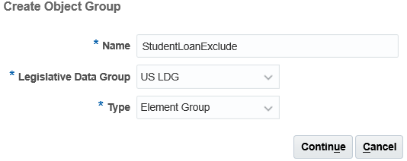

On the **Basic Data** section **set the date** will default to Today’s date. Set the effective date for when the Object Group would be used in payroll calculations. Click **Next** once the date is set.

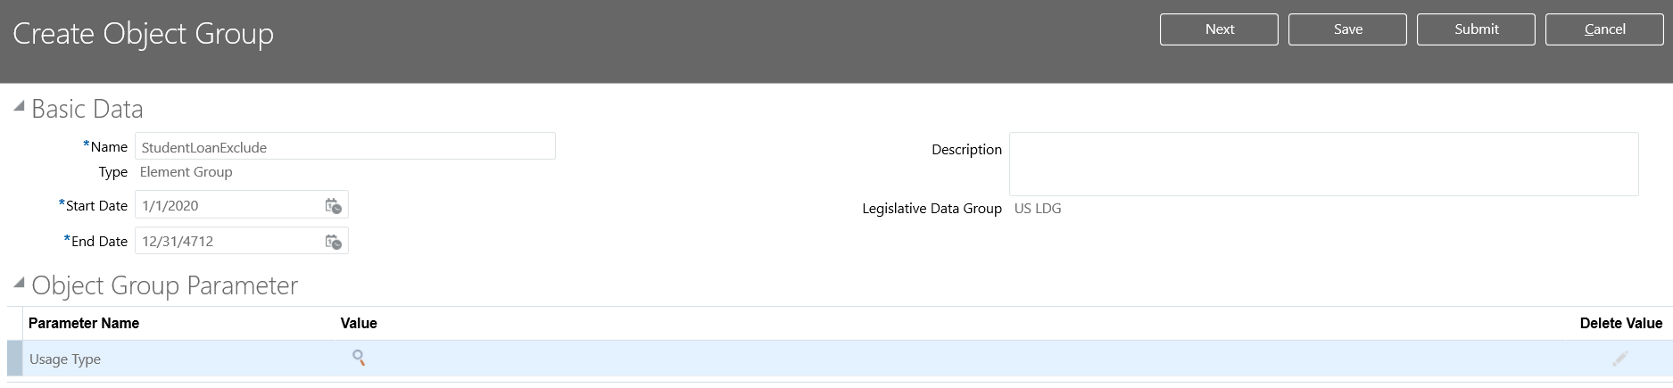

Under the **Element Classification** section include **ALL** classifications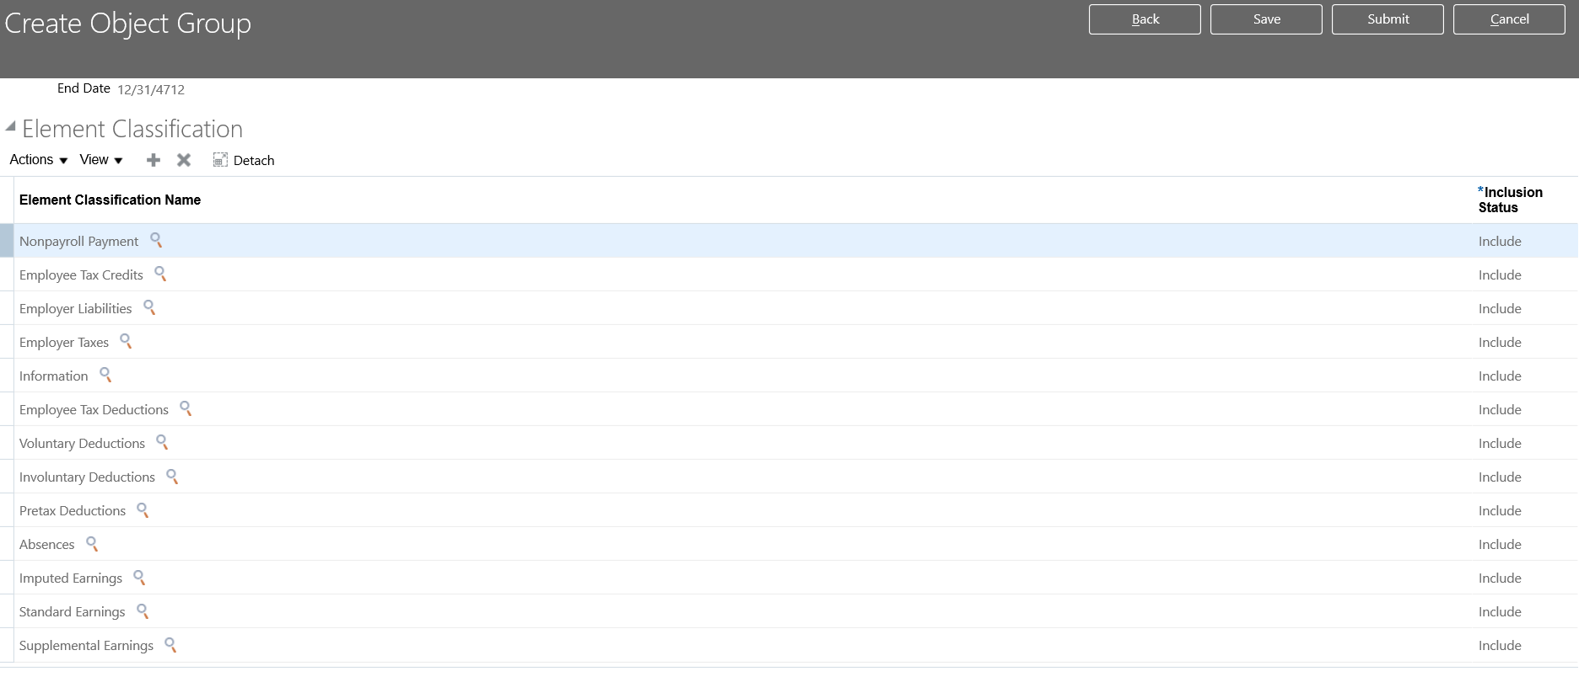

Under the **Element** section add the Federal Student Loan element (unique by costumer) and select **Exclude**.

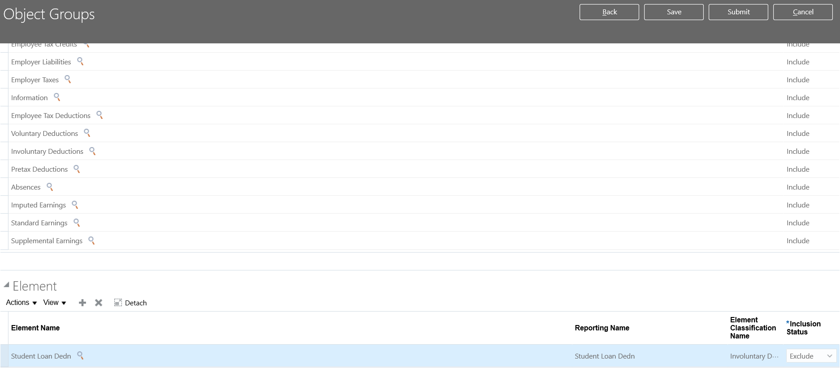

**Submit** the Element Object Group

Option 1 Processing Payroll: Element Set

Calculate Payroll Process

If calculating payroll through the **Calculate** **Payroll** process **include** the **Element Set** that was created.

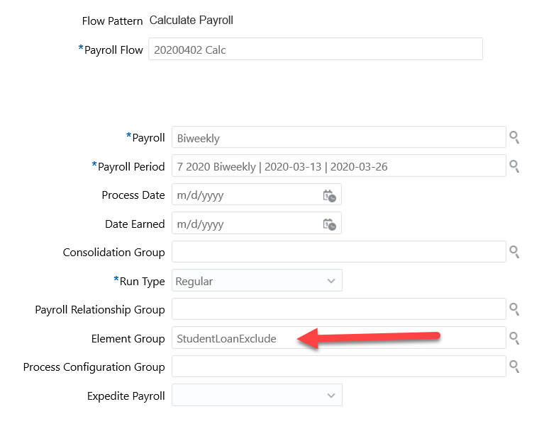

Calculate QuickPay Process

If processing a **QuickPay** than **deselect** the **Federal Student Loan** element prior to calculation as the Element Group is not available.

Option 2 Setup: Skip Rule

Create Skip Rule

Payroll Calculation > Fast Formulas

Create a Skip Rule Fast Formula

* Define a **Name**
* Attach to the United Stated **Legislative Data Group**
* Select Element Skip as the **Type**
* Set the **Effective Start Date**
* Click **Continue**

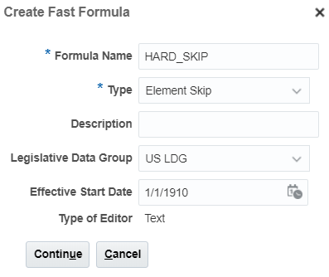

Enter the following in the Text Field:

Default for SKIP_FLAG is 'Y'

SKIP_FLAG='Y'

Return SKIP_FLAG

Click **Submit**

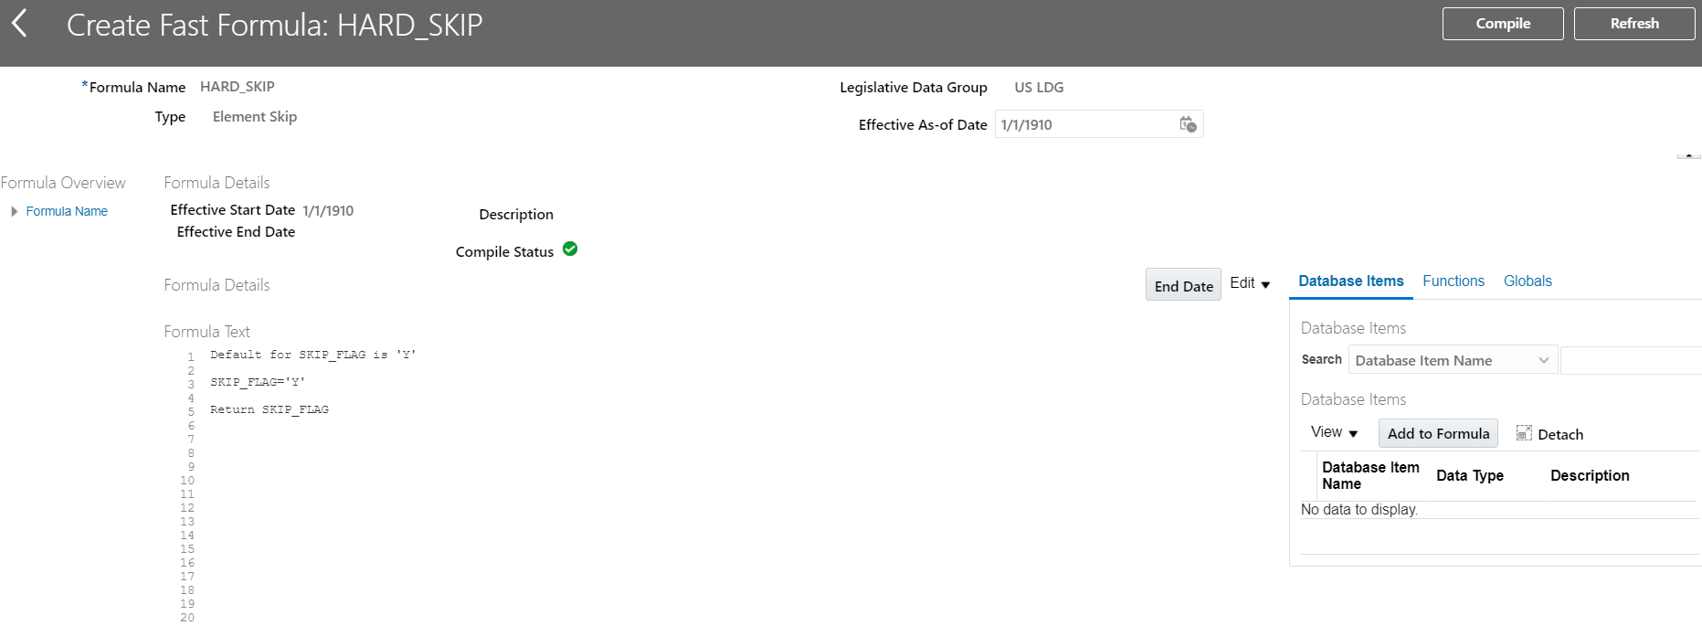

Click **Compile** and **Refresh** until Compile Status is a Green Check Mark.

Correction to Federal Student Loan Element

Payroll Calculation > Element

Pull up the Federal Student Loan Element

* Click Edit > Correct
* Select the Skip Rule that was created
* Submit

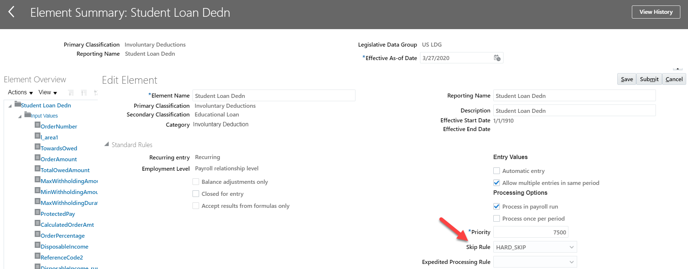

Option 2 Processing Payroll: Skip Rule

Calculate Payroll or QuickPay Process

Utilizing the skip rule there are no changes to how the payroll is currently being processed. The system will skip the Federal Student Loan element from processing in the run.